

**I Wonder… Did we talk about something in class that got you wondering about something? Use Siri, Ask Google, or Echo to find out more about it. What did you wonder about?**

**What did you find out about it?**

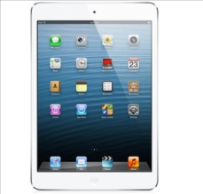

**iPad Apps**

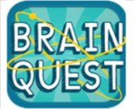

**READING**

**Use the iPad to play a game.**

**BRAINQUEST**

**Level: _____________________ # Correct: ___________**

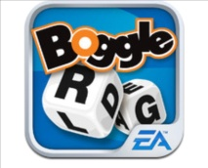

**BOGGLE**

**How many words: _______________**



**HMH READERS Read a Level O or P book.**

**Title of Book: ____________________________ Level: ___**

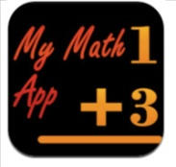

**MATH**

**Use the iPad to play an educational game.**

**MY MATH APP**

**Circle: + - x / Level: Starter or Advanced**



**MATHS MAN**

**How far did you get?: _____________________________**

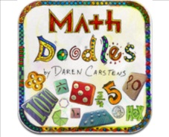

**MATH DOODLES**

**What game? _____________________________________**



**ATTRIBUTES**

**What game? _____________________________________**



**RUSH HOUR**

**Level: ____________________________________________**

C:\Documents and Settings\ryoung\Local Settings\Temporary Internet Files\Content.IE5\KSV163ST\MC900290682[1].WMF

**HUSKY**

**CHALLENGE**

**“A” Average with challenges**

**Level Q**

**MAY**

**M**

**A**

**T**

**H**

**R**

**E**

**A**

**D**

**I**

**N**

**G**

**NOW**

**“A” Average**

**Level O**

**Name: Initials:**

**Week of: Teacher:**

**Husky**

**Star**

**Challenge**

**Complete**

**1 week**

**Challenge**

**Complete**

**4 weeks**

**Challenge**

**Complete**

**3 weeks**

**Challenge**

**Complete**

**2 weeks**

**\*Complete at least 8 challenges to earn a STAR.**



**Challenge Yourself: Do something on your own to challenge yourself. Turn it in to your teacher.**

**What did you do?**

**___________________**

**___________________**

**___________________**

**Teacher Initials: ____**



**www.prodigygame.com/play**

**Username:**

**Password:**

**Levels played: ______________**

**_____________________________**



**Log into Schoology and check the Challenge Folder. Pick one challenge to work on this week. What challenge did you choose?**

**_____________________________________________**

**_____________________________________________**

**_____________________________________________**

**_____________________________________________**



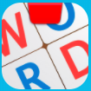C:\Documents and Settings\ryoung\Local Settings\Temporary Internet Files\Content.IE5\LNSYG8E4\MC900434695[1].WMFhttps://encrypted-tbn1.gstatic.com/images?q=tbn:ANd9GcQOLXdF4sHW6IrKptoz3AqXwsE2-CbAN6fH-2gA8X9ajMu0bAKb

**(Must be 85% or higher)**

**AR Score:**

**(Must be 3.0 or above)**

**Level:**

**Title:**

**Read a Just-Right Book and take an AR Test.**

**(Must be 85% or higher)**

**AR Score:**

**(Must be 3.0 or above)**

**Level:**

**Title:**

**Read a Just-Right Book and take an AR Test.**

**Words**

**Numbers**

**Monster**

**Tangrams**

**Coding Awbie**

**Tell about what you did: ____________________________________________**

**____________________________________________________________________**

**____________________________________________________________________**

**________________________________________________________________________**

**(Circle one)**

**sec.**

**Your Time:**

**Practice math skills by playing one level to challenge yourself.**

***(Circle one)***

**Level: 1 2 3 4 5 6 7 8**

**Skill: Add Sub Mul Div Dec Frac Pct**

***(Circle one)***

**Math**

**Shark**

**With What?:**

**Who did you help?:**

**Date:**

**Help someone who is having a difficult time in math.**

***Math***

***Circle your level***

***Circle your level***

**A P B BB**

**%**

**Score:**

**Section Name:**

**Log in to Study Island. Choose a Math Section and score 80% or higher.**

**A P B BB**

**%**

**Score:**

**Section Name:**

**Answer 5 questions on the Quizmo Unit.**

**Tell me one thing you learned: _________________________**

**_______________________________________________________**

**Word:**

**Meaning:**

**As you read, find an unknown word. Write that word below and look up the meaning in a dictionary.**

**D**

**I**

**C**

**T**

**I**

**O**

**N**

**A**

**R**

**Y**

**Circle the levels you completed this week with your Husky P.A.L.**

**Circle One: Multiplication or Division**

**A B C D E F G H I J K L M N O P Q R S T U V W X Y Z**

**Log in to Study Island. Choose a Reading Section and score 80% or higher.**